Studio 11

Name and Student Id: Nicolas Pallant 28785959

Self-Evaluation:

|  |  |  |  |  |  |
| --- | --- | --- | --- | --- | --- |
| Need Help | Work in Progress | Pass | Credit | Distinction | High Distinction |

Task 11.1

Differences between continuous integration & Continous Deployment

* Continuous integration allows for easy releases as integration issues from developers are likely to be solved early as each developer has the most up to date commit of the project, whereas continuous deployment means that integration issues can arise more easily, as developers need to be on top of testing their products, rather than keeping on top of the most recent commits.
* Continuous delivery allows for very easy fixes in problems as constant deliveries are being made, which means the changes are relatively small. Continuous integration on the other hand usually has larger deliveries, which mean harder to fix changes.
* Continuous integration usually has significantly less bugs as bugs are usually found early by other developers and automated tests. Whereas continuous delivery is much more likely to have bugs as every change is straight away pushed to users.

Azure hosted scrrenshot

Azure Hosted URL

<https://fit5032myazurenicolaspallant.azurewebsites.net/>

Git Repository

<https://github.com/Ryukawastaken/FIT5032-Internet-Apps-Dev>

Task 11.2

Software testing approaches

* Unit Testing
* System Testing
* Integration Testing
* Acceptance Training
* Performance Testing

Screenshot of Unit Tests for ASP.nET MVC

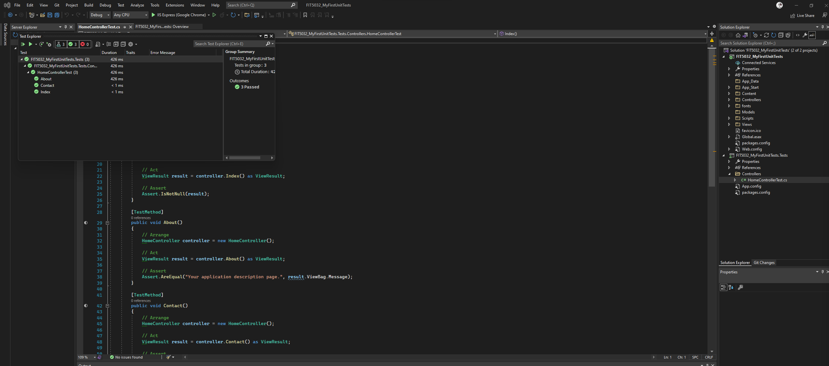

Git repository

<https://github.com/Ryukawastaken/FIT5032-Internet-Apps-Dev>